# A story published by Times Higher Education

# [The architecture professor rebuilding flattened villages (timeshighereducation.com)](https://www.timeshighereducation.com/news/architecture-professor-rebuilding-flattened-villages)

# The architecture professor rebuilding flattened villages

## The science is ‘just physics’ and the human chemistry matters more, says academic behind a sustainable development programme that’s going global

**June 14, 2024**

[**John Ross**](https://www.timeshighereducation.com/author/john-ross)

**Twitter:**[**@JohnRoss49**](https://twitter.com/JohnRoss49)

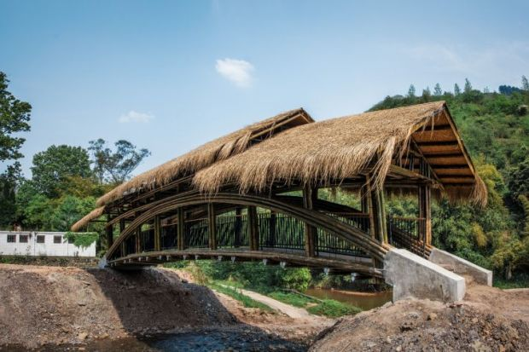

Source: CUHK School of Architecture

Science is important but relationships more so, according to the mastermind of a back-to-the-future construction technique being harnessed to rebuild disaster-struck communities.

[Chinese University of Hong Kong](https://www.timeshighereducation.com/world-university-rankings/chinese-university-hong-kong)(CUHK) architecture professor Edward Ng said academics often asked him the secret behind his “[One University One Village](http://www.1u1v.org/)” programme, which teams universities with villages in China’s Yunnan and Sichuan provinces to reconstruct houses flattened by earthquakes and mudslides.

“I tell them…the scientific part is easy, because it’s universal – it’s just physics,” Professor Ng told Times Higher Education’s Global Sustainable Development Congress in Bangkok. “But the human part is difficult.”

Any show of “ego” could undermine the work, making the villagers feel “despised”, he said. “You really cannot afford to give that wrong impression. There is a slow process of building up respect and trust. You have to do something small. You repair their tap or you clean their toilet.”

An expert in green building and sustainable design, Professor Ng has been rolling his sleeves up in rural China for more than 20 years. In the early 2000s, he began working with remote villages to build bridges from locally sourced materials, allowing children to cross streams safely so that they could attend school.

After the 2008 Sichuan earthquakes rendered millions homeless, Professor Ng pivoted into village reconstruction. His team developed a rammed earth building technique to construct earthquake-resistant buildings. The low-cost approach uses local materials in an adaptation of traditional architecture.

The initiative has spawned collaborations with institutions including Cambridge, Peking and Tsinghua universities. It has won major awards and captured interest from earthquake-prone regions of India, Nepal, Morocco and Turkey.

Professor Ng said the work was prompting social change in the villages, where local women often proved to be the most diligent reconstruction workers. He asked one how they managed it. “We don’t smoke, we don’t drink, and we don’t sleep,” she replied.

He said the team had identified “the poorest and the least respected member” of one community, and decided to build her the best house. “Not the most expensive – it’s actually the cheapest – but it’s the best house in the village. [Now] every villager goes there to have a cup of tea.

“It’s a slow process. It will take 10 years or even longer for this kind of thing to be embedded in the society. [But] it will be a story that we can tell the government and others [so that] we have more resources to continue.”

Programme convener Li Wan said the female workers compensated for their lack of strength with an abundance of “concentration” – a characteristic that had generated discussions about gender pay equality.

“[When] they mix the soil [to] build a wall…they do things very carefully,” Dr Wan said. “We really value this. The quality is good.”

She said relationships were the “bridge” between” the villagers and the academics and student volunteers working alongside them. “We provide the…scientific research and you provide your own local technology [and] skill. It benefits us and benefits you. Everyone is winning.”

Professor Ng said that after one bridge had been built, a local woman had come to thank him. He asked her why she was crying. “She said: ‘Why have you come so late? My son was washed away last year.’ So my message is, whatever you do, do it today.”